C183 Week 7 Lab
Cartographic Data
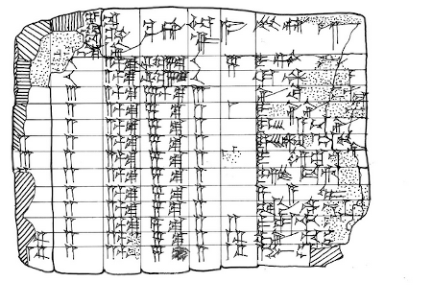

Babylonian Tabular Clay Tablet found near the Euphrates, 3600-4000 years ago

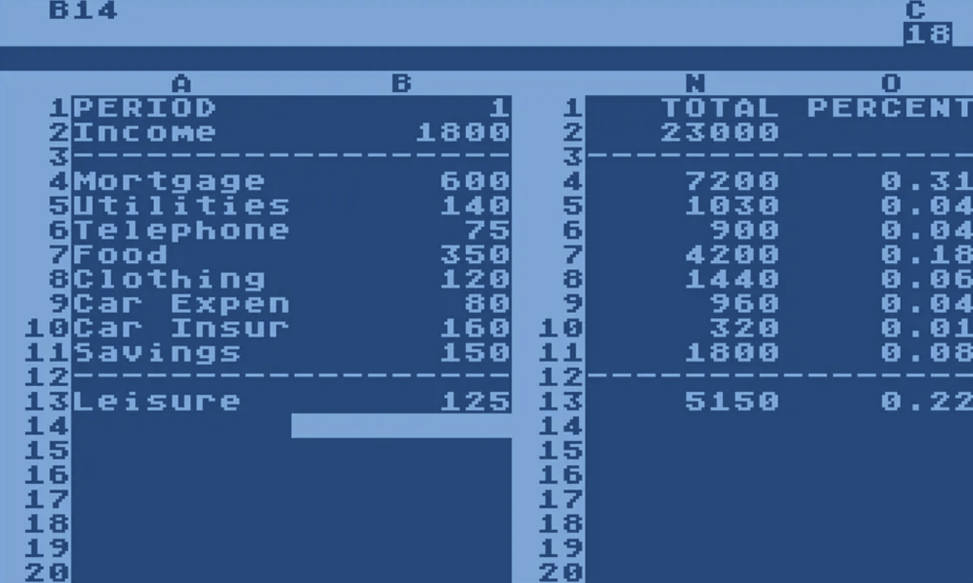

VisiCalc Interface, 1979

Lab Logistics and Deliverable
- Due October 7th, 11:59 PM
- Upload the three deliverables into one combined .pdf on bCourses
  - Completion of Data Retrieval flowchart
  - Completion of Basemap layout in Illustrator
  - Completion of Reflection on practice
0. Lab Seating Arrangement

Before settling into your desktop, please come to the front of the room and retrieve a sticky note. Please try to complete this pre-lab activity in 10 minutes or less so we don’t take time away from the lab activity!

The sticky notes are color coded on three scales: Green (I’ve done mapping before), Yellow (I’ve been exposed and working on my skills), Red/Pink (Help!!! I need to sit next to a green student in order to survive). Please be honest with yourself, this is meant to help us build a community of learning.

Additionally, write on the sticky note the niche skill you can bring to your new studio team (i.e. your row of four classmates). This can range from sound quantitative reasoning, appealing visual design, organized project management, etc.

Now that you have done self-assessment. Re-assign seating amongst yourselves to evenly distribute both skill level and niche assets. Please do not sit near your friend. Introduce yourself to someone new and do some personal growth.

These groups are not “locked” in place for the remainder of the semester. This exercise is meant to ensure come the project weeks (11-14), our lab community knows who to turn to for assistance or feedback. And, it is encouraged to keep working with new people of different skill levels and niche assets.

Experimental Pathway

Prompt

If you are a student who selected a green post-it note at the beginning of the lab, then this optional pathway is for you to push your skills a little further than the foundations. Even if you’re working on the Experimental pathway, it is still encouraged to help your fellow lab mate who is working on the Foundations pathway.

For this pathway, your challenge is to work through the lab trying to recreate a map you find compelling.

An exercise professional cartographers love to do when they’re learning the craft is to emulate the masters (remember at the beginning of the semester when I stressed the importance of precedents? Carl Churchill took the time to study Imhof’s ways, and is now a sensationally talented cartographer). It is advised to choose a map made by a professional cartographer who likely did a blog post on the map they made, or a map made by an organization who likely has official documentation. In general, the map needs to have a list of data sources or else this pathway loses purpose.

The reason this pathway is “experimental” is that you are doing both emulation of the techniques while simultaneously assessing the process.

For those in my evening lab, my pathway task would be to try and recreate that 2022 headline Le Monde map of territorial conflict between Alaska and Russia. By emulating the prowess of the Le Monde graphics journalist, I can deepen my cartographic practice beyond the foundations AND critically assess what the cartographers could have done differently in the scenario (projection, scale/extent, data sources, manipulation of the data, and composition).

Data Assessment and Retrieval

Requirements for phase 1 of the activity
- Identify an object of study for the pathway
- To the best of your ability, retrieve the data the cartographer used on their map
- Create a data retrieval and processing diagram (or flowchart) for your object of study

Your pathway doesn’t have a required criteria for data acquisition. Instead, you are asking yourself critical questions about how the cartographer built their basemap:
- Does the cartographer list sources on the map?
- How would you go about reconstructing the map?
- Is the data they used publicly available or do you need to make a request? If this is the case, that is the point. You need to then reflect on what this means for the larger issues in cartographic representation.
- Would you use a different projection? Why or why not?

This is a brief sample of the analysis questions you can use to assess the strengths and weaknesses of the basemap. It’s also entirely true that you might encounter a map you really admire and see no issues with. In that case, you focus more on understanding why the map works well. And try to recreate it using the principles. Your data exploration process will be messy and non-linear since you have no guide. Embrace the process if you choose this pathway. Remember that the labs are Pass/No Pass.

Remember from lecture Eleanor Lutz’s diagram of how she made the solar system map? Your deliverable for this section is to create a diagram/flowchart for the map you choose to recreate. You are documenting what you think the process is for their construction, analysis and processing of cartographic data.

Given time constraints, and the learning curve for most diagram software, you can draw this by hand or draw using your digital graphics notes app. And it's expected that you probably don’t know the answer (and likely neither does your GSI…), so do your best to ideate given a mix of what you’ve learned so far and your prior knowledge.
Basemap Construction, Data Manipulation and Design

Requirements for phase 2 of the activity
- Perform at least one spatial operation on the data
- If prior GIS experience, perform a spatial analysis method on the data
- Export your map from ArcPro/QGIS layout into Illustrator
- Emulate or counter the cartographer’s design choices: Type, Color, Visual Hierarchy, Pattern, Texture, Brushes, etc.
- Save the completed map as a .pdf

In order to recreate a map that was produced at a professional level, they likely used a litany of spatial data operations to get the precise scale and precision they needed for the map's purpose.

Using your prior knowledge of GIS reflect on what techniques they likely used to manipulate the data, and try to carry out your own manipulation on the data. Spatial Join? Table Join? Clip? Buffer? Filter? Intersection? Proximity? There are even more geoprocessing tools at your disposal.

Utilize at least one geoprocessing tool on your dataset. Given your object of study (map) likely has more stuff going on, you might need to use more (again, don’t stay here until midnight grinding… just have a think and reflect on what you would do if you had ample time, elaborate in the reflection).

You might notice on the professional cartographer’s map a lack of a cheeky OSM or MapBox default basemap. That’s because they built a basemap (secondary data), in addition to the layers of data they are analyzing or emphasizing (primary data).

Your task is to not use a default basemap. I’d rather you submit a map with a blank, white background than use a default. Think about the secondary data the cartographer is using to make the basemap in conversation with the primary data.

NOTE: Maps produced at this level likely involve utilizing raster data (DEMs, Land Cover, etc.). Students in the Foundations pathway don’t touch this as it can cause an information overload. However, you chose to experiment. So, if you encounter a scenario where the basemap data was derived from information embedded within a raster cell. Think of ways to convert the data into vector format (i.e. contours). Or how can you represent the data in raster editing software like Photoshop or GIMP? Beautiful DEM hillshade on NPS Maps emerges from that workflow.

After you utilize a geoprocessing tool, and build a custom basemap, your final task is to begin stylizing the map in Illustrator (a week ahead of schedule). In next week's lab your pathway will be focused on pushing your design capabilities beyond standard representation. This is to ensure you’ve had the chance to have the initial sandbox with GIS layouts in AI, Inkscape, Procreate, etc. I won’t demonstrate this step to you, my hint is look for the .AIX file output option when exporting the map out of the layout frame. ESRI paid good money to have a seamless file agreement with Adobe.

Now that you’ve exported your map to a graphics software, you have the freedom to shape the map’s aesthetic. Experiment with their design choices, and see if you can either replicate or counter their decisions. Ask yourself how the design relates to how the data was classified, and if there might be an alternative approach to showing the feature.

Finish the lab by completing the reflection below. Remember to combine all three of your deliverables into a .pdf (understanding basic file management will get you promoted, I wish I was joking).
Reflection

- Explain how your data and design choices emulate the cartographer, and where they diverge. Why?

- Put a quote from Rankin’s book chapter into conversation with one of the core ideas from Critical Cartography. Think through how the issues within the school of critical cartographic thought emerge in your lab practice. How can you utilize the process of entanglement to improve your cartographic practice as opposed to letting criticism paralyze your inability to produce?

